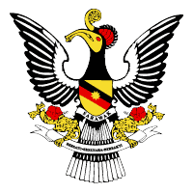
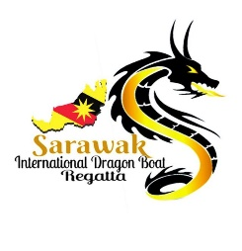
9th SARAWAK INTERNATIONAL DRAGON BOAT REGATTA 2023
PROVISIONAL ENTRY FORM

( Please submit on or before 15th June 2023 )
“PE”
Name Of Association/Club/Team
Country

Contact Person
Phone Number | Mobile | Office | Residence
E-Mail Address

Mailing Address

In the following table indicate the number of teams for each category
 | RACE EVENT | 12 Crews | 22 Crews | 300 metres
1. | International Premier Open
2. | International Premier Mix
3. | International Premier Men
4 | International Premier Women
5 | International Masters Open
6 | Cancer Survivors Open

In the following table, indicate your number of participants.
NO | DELEGATION | GENDER |  | REMARKS
 |  | MALE | FEMALE
1. | Team Manager
2. | Steerer/Coxswain
3. | Drummer
4. | Paddlers
5. | Reserves
TOTAL

Signature :________________ Name of Team Manager :__________________________
Date :________________

