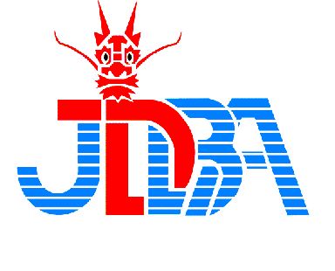
KIX International Friendship Dragon Boat Festival, 2019
Sunday, September 1st, 2019

INFORMATION BULLETIN

To: Dear Dragon Boat Crews

The Organizing Committee of the “KIX International Friendship Dragon Boat Festival, 2019” in conjunction with the Japan Dragon Boat Association, cordially invite crews from around the world to participate in the races, which will be held on Sunday, September 2nd, 2019, using the waterway between phase 1 island and phase 2 island of the Kansai International Airport (KIX).

- Division
1) Premier (20 paddlers) Open: 20 teams (MAX)
2) Premier (20 paddlers) Mixed: 20 teams (MAX)
＊ Women crews are also most welcome. However women crews are requested to race in the Mix category.
3) Small (10 paddlers): 20 teams (MAX) *Local team only
＊ Entry qualifications for small category :
・A team consisting of residents around KIX or ITM airport.
・A team consisting of workers at KIX or ITM airport.
4) First come, first served !!

- Distance
200m only

- Competition Regulations and Racing Rules
KIX International Friendship Dragon Boat Festival, 2019 will comply with the IDBF Competition Regulations and will be conducted under the IDBF Rules of Racing.

- Entry deadline
Friday, August 16th, 2019

- Entry Fees
JYE 70,000 per team (Entry fee plus tent per team at the venue (on the race day only)
※Boxed lunch is NOT included. If you need lunch on the race day, please notify how
many boxed lunches you need.
A boxed lunch with bottled Japanese tea is JYE1,000.

- Method of Payment
Entry fees needs to be transferred to the following designated bank account.

Mitsubishi UFJ bank, Wakayama Branch (497)
SWIFT CODE:BOTKJPJT
Account Number: 4723193
Kanku Dragon Boat Taikai Jimukyoku, Matsumoto Kazuo

- Dragon Boat & Paddles
IDBF Specification dragon boats (Champion boats) are used, and paddlers may use their own paddles provided they comply with IDBF specification (202a). Wooden paddles will be provided by the Organizing Committee in case you don’t have your own paddles.

- Special Attention
- Even though drinks are arranged by the organizer at the race site, all teams are requested to prepare for themselves.
- Alcohol is strictly prohibited during the race from the view point of safety. Teams violated this rule will be disqualified.
- Each team will be provided with 2 garbage bags, and you are requested to carry your own bags back to the information desk when you leave the venue. Please do not leave them at your tent.

- Personal Floating Devices/Aids.
All participants are required to wear PFDs when racing, and approved PFDs will be available at the race site by the Organizing Committee for those who may wish to use them.

- Access to the Racing Venue
The Racing venue is 5 minutes’ walk from the Terminal 2.
Free coach service for DB festival is available from the bus terminal (1st floor of the Aero Plaza) to Terminal 2. It takes about 8 minutes.

- Bus schedule
From 7:00 - 9:00 every 5 – 8 minutes
From 9:00 - 18:00 every 20 minutes

- Attention
There are free coaches for
1) KIX Dragon Boat Festival Participants
2) Terminal 2 (Peach Aviation) Passengers
Please take the free coach service for the Dragon Boat Festival participants.
Also, many passengers & athletes are expected to use the free coaches, please make sure to be well prepared. Thank you for your cooperation.

- Contact information

Kansai Airport Co., Ltd
Contact: Katsumi Takano
katsumi.takano@kansai-airports.co.jp

Japan Dragon Boat Association,
Contact: Makoto Shobu &/or Tatsuya Tani
Email:lilyshobu@gmail.com and/or t.tani@sankei.co.jp
Website: www.jdba-dragonboat.com,
Facebook: http://www.facebook.com/jpdba

We are looking forward to your active participation.

With warmest regards,

Kenichi Sakurai
Chairman
Japan Dragon Boat Association

