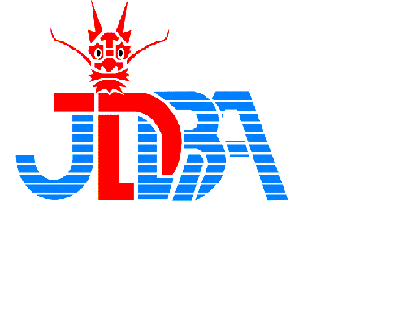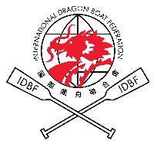
Japan International Dragon Boat Championship, 2018
Organized by the Japan Dragon Boat Association

- Date: Sunday, July 15th,

- Venue: Okawa River, Central Osaka.
Access: Tenmabashi station of Keihan line & Subway, Tanimachi line

- Race Distance: 250m only (specially arranged straight course).

- Race Category: Standard & Small boat
Standard boats are used for small boat races.
Open, Women, Mixed and Senior.

- Team Composition:
- Small Boat (DB12): 10 paddlers, 1 steerer, 1 drummer, 3 reserves.
Minimum 8 paddlers. (standard boats are used)
- Standard Boat (DB22): 20 paddlers, 1 steerer, 1 drummer, 3 reserves.
Minimum 16 paddlers.

- Competition Regulations and Rules of Racing
The race will be conducted in accordance with the IDBF Competition Regulations & Rules of Racing.

- Equipment:
- Dragon Boat: IDBF authorized Champion Standard boat
- Paddles: Paddlers may use their own paddles provided they comply with IDBF specification (202a). Wooden paddles will be provided by the Organizing Committee in case you don’t have your own paddles.
- Drummer, Paddlers and Steerer must wear floating vest from the view point of safety. Floating vests are prepared by the Organizing Committee at the race site.
- Entry Condition
- All teams are requested to obtain endorsement form the IDBF recognized Federation/Association of their own country/region.
- Insurance: All teams are requested to have Accident Insurance. The competition is insured by the Organizing Committee.
- Visa: In case you need a support to obtain visa after making entry, please contact the Organizing Committee.

- Entry Fee: Special discount arrangement will be made for the foreign teams.
Standard boat – JYE100,000
Small boat - JYE50,000

- Payment: Entry Fee is to be paid into the dedicated Account.

- Arrangement by the Organizing Committee
- Team’s tent (5.4m x 3.6m) will be provided by the Organizing Committee.
- Lunch (Chicken Curry) will be provided.
- Water supply (bottles of water) will be provided.
- Assistant (interpreter) will be arranged if needed.
- Foreign teams can make entries to both Small and Standard category only when the situation allows.
- Practice can be done in the afternoon of Saturday, July 14th at the race course.

- Team Managers’ Meeting: Team managers’ meeting is scheduled at the Osaka Castle Hotel right in front of the racing course in the evening of Saturday, July 14th. All team managers are requested to attend the meeting.

- Special Attention:
- In these days, rush of foreign tourists to Japan make it VERY difficult to book hotels. The Organizer tries best effort to book hotels for foreign teams, but many tourists mention that it may be easier to arrange hotel accommodation from outside of Japan through the internet. Let’s see !!
- Alcohol is strictly prohibited during the race. Teams violated this rule will be disqualified.

- Payment
Entry fee is to be paid into the dedicated account detailed below.
- Bank: Sumitomo Mitsui Banking Corporation
- Branch: Nanba Branch
- Branch code: 111
- Swift code: SMBC JP JT
- Account Name: Nihon doragonboto kyokai Tani Tatsuya
- Account Number: 7665342
- Bank Address: 5-1-60 Nanba, Chuo-ku, Osaka-shi, Osaka
- TEL: +81-6-6632-3041

- Contact Information:
Japan Dragon Boat Association
2-1-57, Minatomachi, Naniwa-ku, Osaka 556-8663, Japan
TEL: +81-6-6633-5833, FAX: +81-6-6633-5695
JDBA:www.jdba-dragonboat.com/

Contact Person
Makoto Shobu, Vice Chairman of the Japan Dragon Boat Association
lilyshobu@gmail.com

