6th Korea Open Busan International Dragon Boat Festival
(since 2010)
Suyeong River, APEC Naru Park, Haeundae, Busan, Korea
31 Aug - 4 Sep, 2016(Race Day 2 - 3 Sep)
Information Bulletin

Ⅰ. Introduction

To. All International Dragon Boat Crew Members
The Organizing Committee of the 6th Korea Open Busan International Dragon Boat Festival in conjunction with the Busan Metropolitan City, the second largest city in Korea, cordially invite your team to participate in this festival which will be held from Wednesday the 31st of Aug to Sunday the 4th of Sep 2016, at the beautiful Suyeong River, APEC Naru Park in Haeundae, Busan, Korea.

Ⅱ. Hosted by
Busan Metropolitan City Office
Haeundae District Office, Busan
Suyeong District Office, Busan
Korean Dragon Boat Association
Sea Explorer’s of Korea

Ⅲ. Tentative Schedule

Date | Contents
29 Apr (Fri) | Provisional Entry Form (by E-mail)
30 Jun (Thu) | Confirmed Entry Form (not allowed to change any more)  - individual photograph, name list and team introduction form must be submitted to organizing committee  - the deadline of Entry Fee payment
30 Aug(Tue) | Evening : Race Officials’ Meeting
31 Aug(Wed) | Crews Arrival, Registration  Crew Training(10 am ~ 3pm)
1 Sep(Thu) | Crews Arrival, Registration  Crew Training(10am ~ 3pm)  7pm - Team Managers’ Meeting
2 Sep(Fri) | The First Race Day  * 11am - Opening Ceremony  - Premier 200M (DB12) - Heat, Semi Final, Minor Final, Grand Final-  - Premier 200M (DB22) - Heat, Semi Final, Minor Final, Grand Final  * Special Event – Kayak King  2-Seater Kayak - 200M Straight Course  - Awards Ceremony
3 Sep(Sat) | The Second Race Day  - Premier 500M (DB12) - Heat, Semi Final, Minor Final, Grand Final  - Premier 500M (DB22) - Heat, Semi Final, Minor Final, Grand Final  - Awards Ceremony  - Premier 1000M (DB22) - Ranking  * 7pm – Celebration Party
4 Sep(Sun) | - International Teams Departure

Ⅳ. Competition Regulations and Rules of Racing

A. Competition Regulations and Race Rules
1. The races will be run in accordance with the IDBF Competition Regulations &
Rules of Racing with Specific KDBA Entry Rules.
2. There will be an exceptional Competition Regulations & Rules of Racing by Organizing Committee as their discretionary authority.
3. The detailed Race Rules will be released on the separate attachment or announced on the day of team managers meeting.
4. All team members should be familiar with the Competition Regulations and
Race Rules.

B. Team Manager
1. Each Team must have a Team Manager who in charge of all the
administrative procedures.
2. Team Managers are required to understand and comply with all the
Competition Regulations and Rules of Racing.
3. The team manager is the only person with the authority to protest and
appeal.

C. Equipment Details
1. Dragon Boat – Small Boat (IDBF Champion DB 912 Model)
Standard Boat (IDBF Champion DB 1222 Model)
2. Paddles - Any type of IDBF recognised paddle. Competitors may use their own paddles, provided that they comply with IDBF specification.
If you don’t have your own paddle, a wooden paddle will be provided by Organizing Committee at the race site.

D. Team Composition
1. Member of Boat
a) Small Boat (DB12) – 10 Paddlers, 1 Steerer, 1 Drummer, 2 Reserves
b) Standard Boat (DB22) – 20 Paddlers, 1 Steerer, 1 Drummer, 4 Reserves
*minimum 16 Paddlers, 1 Steerer, 1 Drummer

2. Restriction of Composition
a) Open : no restrictions on Gender, Age
b) Women : no restrictions for Steerers, Drummers and Paddlers women only
c) Mixed : standard boat(min8, max12 women)/small boat(min4, max6 women)

Ⅴ. Race Category and Distance
A. Dragon Boat
Category |  |  | Distance | Date |  | Prize
 |  |  |  | 2nd Sep | 3rd Sep
Class | Small Boat  (DB12) | Premier Open | 200M | ● |  | Trophy, Medal
 |  | Premier Women
 |  | Premier Mixed
 |  | Premier Open | 500M |  | ●
 |  | Premier Women
 |  | Premier Mixed
 | Standard Boat  (DB22) | Premier Mixed | 200M | ●
 |  | Premier Mixed | 500M |  | ●
 |  | Premier Mixed | 1000M |  | ●
* Competition Classes with less than 5 Entries by 31st July will be cancelled.
B. Special Event – Kayak King(the 2nd of Sep, 2016)
1. Entry – The entry is only for 30 teams, the application is on a first
come first served basis.
2. Team Composition - 1 team consists of 2 members.
3. Type of Boat - 2-seated, sit-on kayak
4. Race Division – Premier Mixed, 200M Straight Course
5. Awards – 1st to 5th place will receive Prizes.

Ⅵ. Prizes
The Trophy and Medals will be granted to 1st Place to 3rd Place
* Small Boat - 1 Trophy and 14 Medals for each team
* Standard Boat - 1 Trophy and 26 Medals for each team

Ⅶ. Entry
A. Entry Condition
1. All teams are required endorsement from the IDBF recognized Association/
Federation of their Country.
2. Endorsements must be signed by the President of the IDBF recognized Association/Federation of their Country.
3. Exceptions may be made at the discretion of the Organizing Committee.
4. Insurance
All teams are required to have Accident Insurance. The competition is
insured by Organizing Committee separately.
5. Visa
If you require any assistance in Visa application after you submit the participants list, please contact the Organizing Committee.

B. Entry Fee
30 USD per person

C. Payment
Entry Fee is to be paid into the dedicated Account detailed below.
- Bank: Name : BUSANBANK - Branch Name : MARINECITY BRANCH
- BANK BRANCH CODE : 0321718 - Swift Code : PUSBKR2PXXX
- Account Holder : Hankuk Haeyang Sonyendan Busan Yeonmeng
- Account Number : 101-2022-1307-06
- Bank Address : BUSAN HAEUNDAEGU WOODONG 1435 KOREA

Ⅷ. Arrangement from Organizing Committee
A. Free Accommodations
(including Breakfast, 4 Nights, check in 31st Aug/ check out 4th Sep)
* Please be aware that we offer the free accommodation up to 28 members
per club(1 manager, 1 coach, 26 athletes). The accommodation will be assigned on a first come first served basis
* Hotel information will be updated soon.
B. Transportation (Airport to Hotel/ Hotel to Race Venue)
*Competing crews are encouraged to arrive in Busan (Gimhae) International Airport at Busan City or Busan Train Station
* There will not be arrangements for transport from Incheon Airport
C. Lunch box on Race days (2 – 3 Sep)
* If you have any special dietary requirements, provide information in the Confirmed Entry form.
D. Celebration Party

Ⅸ. Race Venue
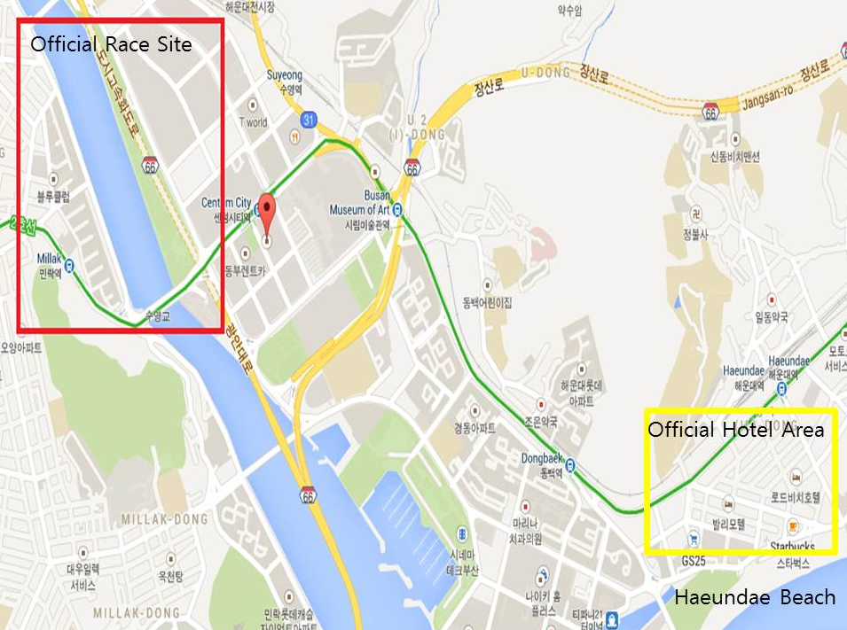
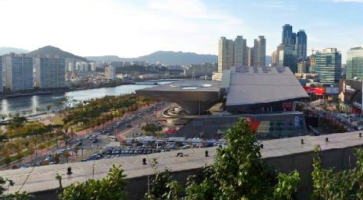
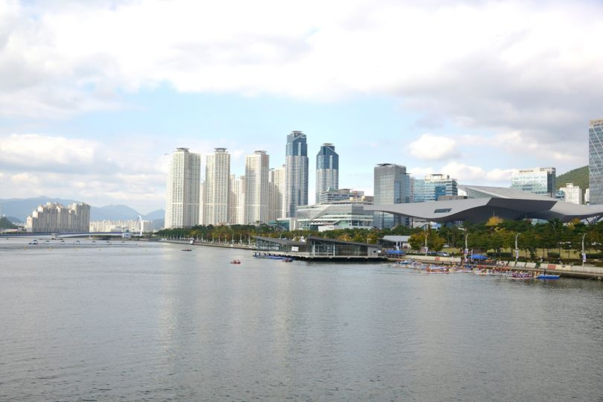
Ⅹ. Contact Information
A. Organizing Committee
1. Contact Person
Choi Gabin , the Manager of Korean Dragon Boat Association
2. Enquiry
T. +82-51-743-5855
E-mail. bdba@hanmail.net
FB. Gabin Choi, aquabin0111@naver.com

B. Korean Dragon Boat Association
T. +82-2-3285-3369
E-mail. dragonrok@daum.net

