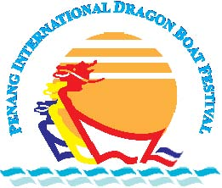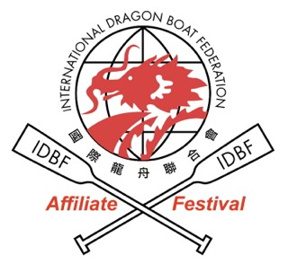

35TH PENANG INTERNATIONAL DRAGON BOAT FESTIVAL 2014

CONFIRMED ENTRY FORM
(DEADLINE FOR SUBMISSION: 15th MARCH 2014)

Name of Crew : _____________________________________________
团队名称
Name of State/Country : _____________________________________________
团队国籍
Name of Crew Manager : _____________________________________________
领导姓名
No. of crew members : male名男队员 ______female名女队员 ______
Total队伍成员_________
Telephone No. / Fax : (H/P) 手机__________________(Fax) 传真__________________
联络号码 / 传真
E-mail Address : _____________________________________________
电子邮件
Races Participating : (Please indicate the number of entries on the blank……)
赛事参与及次数 (请在格内填写参赛次数)

- Malaysia Premier Open (22 Racers) - …………..(200m) / ………… (500m)
- International Premier Open (22 Racers) - …………..(200m) / ………… (500m)
- International Premier Women (12 Racers) - …………(200m) / ……….. (500m)
- International Premier Mixed (12 Racers) - …………..(200m) / ……...… (500m)
- International Senior 40 Open (12 Racers) - …………(200m) / …….….. (500m)
- International Senior 40 Mixed (12 Racers) - …………(200m) / ……….. (500m)
- International Junior U23 Open (12 Racers) - …………(200m) / …….... (500m)
- International Junior U23 Mixed (12 Racers) - …………(200m) / ……... (500m)

Total no.of events : __________
项总共参与的项目
Total entry fees paid & date : US$ / RM ___________ (缴付日期)______________________
总共缴付的参赛费与缴付日期
Proof of payment (attach) : * yes 有 / no 无

Mode of Payment : *Telegraphic Transfer / Credit Card / Direct Bank-in
附带缴费证据
Crew Manager’s Signature : _______________________ Date : _______________
领队签名 日期

*Delete whichever not appropriate

Payment Mode

All payments can be made by telegraphic transfer (US$), direct bank-in (RM) or credit card no later than the relevant deadlines, thereafter email a copy of the transaction slip to secretarypidbf@gmail.com

Bank charges imposed for telegraphic transfer are to be absorbed by crews themselves, meanwhile a 3% commission will be imposed for credit card payments.

- Bank details for Telegraphic Transfer and Direct Bank-in are as follows:

Account Name | Penang International Dragon Boat Festival
Bank | Maybank Islamic Berhad
Address | No.1 Arked Ria 1, KOMTAR, 10000 Penang, Malaysia
Swift Code | MBBEMYKL
Account No. | 557054501765
Reference | Please provide name of crew and description of payment being made (eg. Entry Fee)

- For Credit Card payment, please furnish the followings:

- Name in the credit card : ………………………………………………..
- Credit card number : ………………………………………………..
- Type of card : *Master/Visa
- Issuing bank : ………………………………………………..
- Expiry date : ………………………………………………..

Contact Information

Mailing Address: | EXCO Penang State Tourism Development & Culture  Level 53, Komtar  10350 Penang  Malaysia
Contact: | Tel: +604-650 5136  +6012-4830448  Fax: +604-2280448
Email: | secretarypidbf@gmail.com
Website: | www.penangdragonboat.gov.my
Facebook: | https://www.facebook.com/penangdragonboat

