Form 1 - Preliminary Entry Form | Page 1/2
Please submit to hkdba@hkolympic.org on or before 31 Dec 2013
Team Name | (Eng)
 | (Chi)
Team name must be provided in both Chinese and English. Otherwise it will be decided by the Organiser and no protest will be accepted.
Contact Person |  | Contact No.
E-mail
Address
Number of entries (Please fill in number of participating teams)
Categories | Standard Boat 500m | Small Boat 500m | Fee (HK$)
International Championships - Oversea Teams Only
International Open
International Mixed
International Women
International Paradragon
Local Championships – Local Teams Only
Open
Mixed
Women
Senior O40
Inter-Company
Travel Industry & Hotel
Bank
Junior U23 |  |  | --
Welcome all teams which have joined the above listed category
Fancy Costume | Costume Theme： |  | --
Please indicate with “✓”:
For the use of the above contacts:
□  □ | 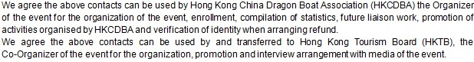
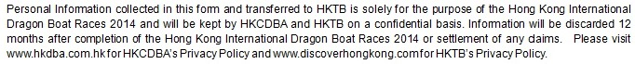

Team Manager |  | Signature |  | Stamp of Organisation |  | Date

Form 1 - Preliminary Entry Form | Page 2/2
Please submit to hkdba@hkolympic.org on or before 31 Dec 2013

Team Name
Email address

Arrival & Departure
Planned arrival date | Morning /Afternoon / Evening
Planned departure date | Morning / Afternoon / Evening

The following items are subject to separate charges. Please refer to the bulletin for detail information. (Please indicate with“✓”)

We □ require (Each HK$600/3 days)
□ do not require marquee
We □ require visa ( _________ persons need visa)
□ do not require visa.
We □ require accommodation ( Single Room_______ Room; Double Room_______ Room)
□ do not require accommodation.
We □ require extra transport arrangement ( Date: _____________________________ )
□ do not require extra transport arrangement.
We □ will attend celebration dinner (_____table require)
□ will not attend celebration dinner.
For the use of the above contacts:
□

□

Declaration
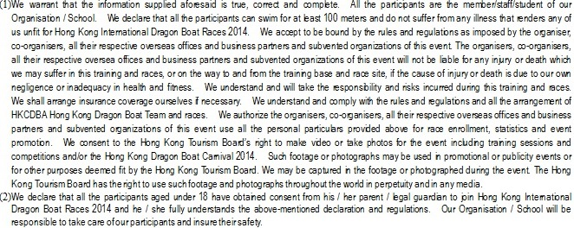
Team Manager |  | Signature |  | Stamp of Organisation |  | Date

Form 2 - Crew List | Page 1/2
Please submit to hkdba@hkolympic.org on or before 28 Feb 2014
Please fill in BLOCK Letters
Team Name
Category

Full name in English | Sex | Athlete Registration No. |  |  |  |  |  |  |  | Full name in English | Sex | Athlete Registration No.
- Team Manager |  | Local Mobile Phone No.：

Form 2 - Crew List | Page 1/2
Please submit to hkdba@hkolympic.org on or before 28 Feb 2014

Please fill in BLOCK Letters
Team Name
Category

Full name in English | Sex | Athlete Registration No. |  |  |  |  |  |  |  | Full name in English | Sex | Athlete Registration No.
* Team members who do not have 2014 HKCDBA athlete registration card should submit application of Athlete Registration together with this form. Please leave the box of Athlete Registration Number blank.

Form 3 - Liability Release | Page 1/5
Please submit to hkdba@hkolympic.org on or before 28 Feb 2014
Please fill in BLOCK Letters
Team Name
Category
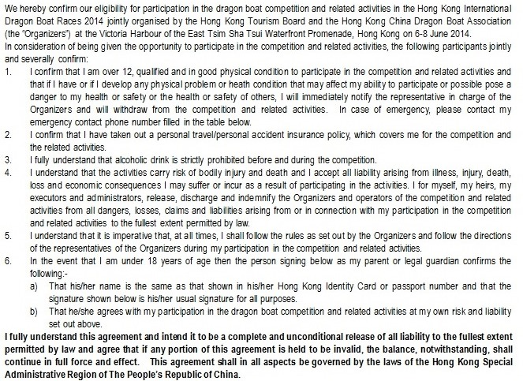
 | Participants Name | HKID / Passport No  (1st 4 digits) | Age | Emergency Contact and Phone No. | Participant Signature | Parent / Legal Guardian’s  Name & Signature for participants aged under 18 | Date
Team
Manager

Form 3 - Liability Release | Page 2/5
Please submit to hkdba@hkolympic.org on or before 28 Feb 2014
Please fill in BLOCK Letters
Team Name
Category
 | Participants Name | HKID / Passport No  (1st 4 digits) | Age | Emergency Contact and Phone No. | Participant Signature | Parent / Legal Guardian’s  Name & Signature for participants aged under 18 | Date

Form 3 - Liability Release | Page 3/5
Please submit to hkdba@hkolympic.org on or before 28 Feb 2014
Please fill in BLOCK Letters
Team Name
Category
 | Participants Name | HKID / Passport No  (1st 4 digits) | Age | Emergency Contact and Phone No. | Participant Signature | Parent / Legal Guardian’s  Name & Signature for participants aged under 18 | Date

Form 3 - Liability Release | Page 4/5
Please submit to hkdba@hkolympic.org on or before 28 Feb 2014
Please fill in BLOCK Letters
Team Name
Category
 | Participants Name | HKID / Passport No  (1st 4 digits) | Age | Emergency Contact and Phone No. | Participant Signature | Parent / Legal Guardian’s  Name & Signature for participants aged under 18 | Date

Form 3 - Liability Release | Page 5/5
Please submit to hkdba@hkolympic.org on or before 28 Feb 2014
Please fill in BLOCK Letters
Team Name
Category
 | Participants Name | HKID / Passport No  (1st 4 digits) | Age | Emergency Contact and Phone No. | Participant Signature | Parent / Legal Guardian’s  Name & Signature for participants aged under 18 | Date

Form 4 - Health Questionnaire | Page 1/4
Please submit to hkdba@hkolympic.org on or before 28 Feb 2014
Please fill in BLOCK Letters
Team Name
Category
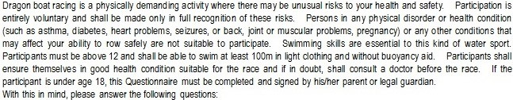
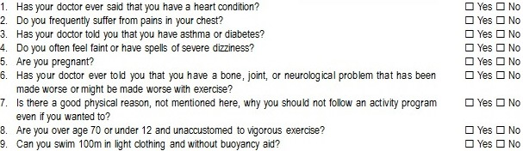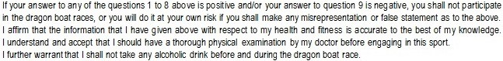
 | Question  Participants Name | Answer to the above questions  Please fill Y for Yes or N for No |  |  |  |  |  |  |  |  | Participant Signature | parent / legal guardian’s  Name & Signature for participants aged under 18 | Date
 | Question  Participants Name | 1 | 2 | 3 | 4 | 5 | 6 | 7 | 8 | 9 | Participant Signature |  | Date
Team
Manager

Form 4 - Health Questionnaire | Page 2/4
Please submit to hkdba@hkolympic.org on or before 28 Feb 2014
Please fill in BLOCK Letters
Team Name
Category
 | Question  Participants Name | Answer to the above questions  Please fill Y for Yes or N for No |  |  |  |  |  |  |  |  | Participant Signature | parent / legal guardian’s  Name & Signature for participants aged under 18 | Date
 | Question  Participants Name | 1 | 2 | 3 | 4 | 5 | 6 | 7 | 8 | 9 | Participant Signature |  | Date

Form 4 - Health Questionnaire | Page 3/4
Please submit to hkdba@hkolympic.org on or before 28 Feb 2014
Please fill in BLOCK Letters
Team Name
Category
 | Question  Participants Name | Answer to the above questions  Please fill Y for Yes or N for No |  |  |  |  |  |  |  |  | Participant Signature | parent / legal guardian’s  Name & Signature for participants aged under 18 | Date
 | Question  Participants Name | 1 | 2 | 3 | 4 | 5 | 6 | 7 | 8 | 9 | Participant Signature |  | Date

Form 4 - Health Questionnaire | Page 4/4
Please submit to hkdba@hkolympic.org on or before 28 Feb 2014
Please fill in BLOCK Letters
Team Name
Category
 | Question  Participants Name | Answer to the above questions  Please fill Y for Yes or N for No |  |  |  |  |  |  |  |  | Participant Signature | parent / legal guardian’s  Name & Signature for participants aged under 18 | Date
 | Question  Participants Name | 1 | 2 | 3 | 4 | 5 | 6 | 7 | 8 | 9 | Participant Signature |  | Date

Form 5 - Crew List Alternation Form 賽員名單更改表格 | Page1/1頁
請於2014年6月3日前電郵至hkdba@hkolympic.org
Please submit to hkdba@hkolympic.org on or before 3 Jun 2014

Please fill in BLOCK Letters. 請以正楷填寫
Team Name隊伍名單
Category參加組別

New member 新賽員
 | Full name in English  英文全名 | Sex  性別 | Athlete Registration No.  運動員註冊編號

Withdrawn member 退出賽員
 | Full name in English  英文全名 | Sex  性別 | Athlete Registration No.  運動員註冊編號

Team Manager Signature with stamp領隊簽署與蓋印 |  | Date日期
行政費 Admin Charge：HK$ _______ /名person x ______名運動員Athlete(s) = HK$ ________

交表日期  Form Submission Date | 支票號碼  Cheque No. | 銀行  Bank | 入賬日期  Cheque Clearing Date

