Suyeong River, APEC Naru Park in Haeundae, Busan, Korea
1st - 6th Oct, 2013

INFORMATION BULLETIN NO.2
To. All International Dragon Boat Crew Members
The 3rd Korea Open Busan International Dragon Boat Regatta will be held from Tuesday 1st Oct 2013 to Sunday 6th Oct 2013, at the Suyeong River, APEC Naru Park in Haeundae, Busan, Korea. We cordially would like to invite all of international dragon boat club teams and crews. The following information would be provided for all the Dragon Boat Crew Members.
- Divisions, Racing & Competition Classes and Distances
- Divisions
Only Premier - the primary class of racing.
There are no restrictions on competitor’s age.
- Racing & Competition Classes
- Open : no restriction on crew composition(gender)
- Women : for female crews only including the Drummer and Steerer
- Mixed : DB22 - minimum of 8 and maximum of 12 female paddlers
DB12 - minimum of 4 and maximum of 6 female paddlers
- Distance – 200m & 500m only
- Number of Competitors
DB22 – 18 to 20 Paddlers, 1 Drummer, 1 Steerer, 4 Reserves
DB12 – 8 to 10 Paddlers, 1 Drummer, 1 Steerer, 2 Reserves

- Race Category

 | Category | 200m | 500m
DB22 | Premier Open
 | Premier Women
 | Premier Mixed

 | Category | 200m | 500m
DB12 | Premier Open
 | Premier Women
 | Premier Mixed

- Racing Days
- Racing Day1 (Thu, 3rd Oct, 2013)
- 200m DB22 Open, Women, Mixed
- 200m DB12 Open, Women, Mixed

- Racing Day2 (Fri, 4th Oct, 2013)
(1) 500m DB22 Open, Women, Mixed
(2) 500m DB12 Open, Women, Mixed

- Competition Regulations & Rules of Racing
This race will comply with IDBF Competition Regulations and will be under the IDBF Rules of Racing. May be exceptions depending on the situations.

- Entries
Open to all Dragon Boat Club teams.
* Final Entries : Monday, 9th Sep, 2013
Final Entries must also include the following : to Organizing Committee
1) payment in full(entry fee, accommodation fee)
2) Entry Form, members’ list and accreditation photos, teams introduction
3) Race Application form(each race)
6. Entry Fee
Entry Fees payment USD$20/per person

7. Prizes
Trophies, medals and prize money will be awarded to the winners as follows.
** Prize Money (Measure-10,000KRW)
Distance | Category |  | 1st | 2nd | 3rd | 4th | 5th | 6th | 7th | 8th | Remarks
200m | DB12 | Open | 100 | 90 | 80 | 70 | 60 | 50 | 50 | 50
 |  | Women | 100 | 90 | 80 | 70 | 60 | 50 | 50 | 50
 |  | Mixed | 100 | 90 | 80 | 70 | 60 | 50 | 50 | 50
 | DB22 | Open | 100 | 90 | 80 | 70 | 60 | 50 | 50 | 50
 |  | Women | 100 | 90 | 80 | 70 | 60 | 50 | 50 | 50
 |  | Mixed | 100 | 90 | 80 | 70 | 60 | 50 | 50 | 50
500m | DB12 | Open | 100 | 90 | 80 | 70 | 60 | 50 | 50 | 50
 |  | Women | 100 | 90 | 80 | 70 | 60 | 50 | 50 | 50
 |  | Mixed | 100 | 90 | 80 | 70 | 60 | 50 | 50 | 50
 | DB22 | Open | 150 | 140 | 130 | 120 | 110 | 50 | 50 | 50
 |  | Women | 150 | 140 | 130 | 120 | 110 | 50 | 50 | 50
 |  | Mixed | 150 | 140 | 130 | 120 | 110 | 50 | 50 | 50

8. Outline Programme

Date | Time | Event
1st Oct (Tue) | 0900-1500 | Crews Arrival, Registration, Check in, Training
2nd Oct (Wed) | 0900-1500 | Crews Arrival, Registration, Check in, Training
 | 1600-1700 | Crew Managers Meeting
3rd Oct (Thu) | 1000-1100 | Opening Ceremony
 | 1100-1230 | 200m(DB22,DB12)-Open, Women, Mixed
 | 1400-1700 | 200m(DB22,DB12)-Open, Women, Mixed
 | 1700-1730 | Awards Ceremony
4th Oct (Fri) | 1000-1200 | 500m(DB22,DB12)-Open, Women, Mixed
 | 1400-1700 | 500m(DB22,DB12)-Open, Women, Mixed
 | 1700-1800 | Awards Ceremony, Closing Ceremony
5th Oct (Sat) | 0900-1800 | Busan City Tour or Free Time
 | 1900-2100 | Celebration Party
6th Oct (Sun) | 0900- | Crews Departure

9. Reference
- Transportation (between Venue/Airport(GimhaeAirport) to Hotel),
Lunch(on Racing days – 3rd, 4th), Celebration Party would be hosted by Organizing Committee. The Accommodation list would be attached.

- Payment should be made by electronic transfer to the followings.
Account Information
Name of Bank | Busan Bank, Haeundae Branch
Address | 741-1, Gwangan4-dong, Suyeong-gu, Busan (613-104)
Swift Code | PUSBKR2P
Account Holder's Name | BUSAN MUNHWA BROADCASTING CORP.
Account No. | 039-09-000099-2

10. Contact Information
- official Organizing Committee(Entries, Registration, Request)
: bdba@hanmail.net / +82-51-743-5855
- charged with accommodation, tour
: 2013dragonboat@gmail.com / +82-51-754-6988

11. Official Hotel List *Please note that bed type may change depending on the situation
1) Homers Hotel
193-1, Gwangan2-dong, Suyeong-gu, Busan /
http://www.homershotel.com/english/main.php
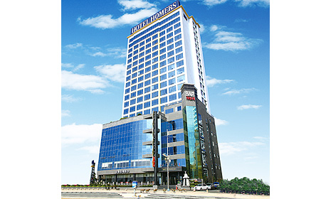
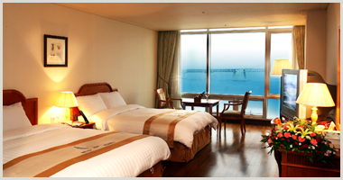
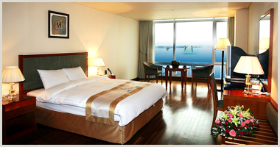
The beautiful beaches of Busan attract visitors from around the world, and Homers Hotel has everything you need for a memorable stay in the ‘summer capital’ of Korea. The hotel is close to the serene blue sea and Gwangan Diamond Bridge. It is well connected to the surrounding area by the subway and bus services. The business rooms at Homers Hotel offer spectacular views of Mountain and the city centre, and VIP rooms have beach views. All rooms are spacious and tastefully decorated; they are equipped with air-conditioning, internet connection and satellite TV. Other amenities available to guests include fitness centre and sauna, hair salon, parking and laundry services.

ROOM TYPE | PRICE(per room/2pax) | REMARKS
Deluxe Mountain (Double/Twin) | $100 | Breakfast $15
Deluxe Ocean (Double/Twin) | $150 | Breakfast $15

2) Aqua Palace Hotel

192-5 Gwangan 2-dong, Suyeong-gu, Busan
http://www.aquapalace.co.kr/eng/

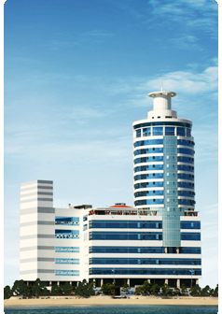
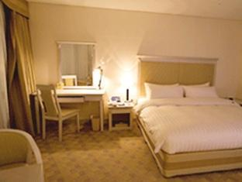
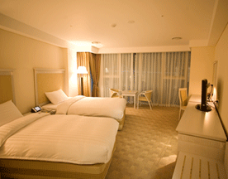
Situated on the beach in the heart of Busan, Hotel Aqua Palace is close to Gwangalli Beach, Gwangan Diamond Bridge, and Busan Museum of Modern Art. Additional attractions near this hotel include BEXCO and UN Memorial Cemetery. Hotel Aqua Palace has a water park, an indoor pool, and a spa tub. There is a business center on site. This beach hotel offers a coffee shop/café and a bar/lounge. Additional amenities include a fitness facility, a sauna, and laundry facilities.

ROOM TYPE | PRICE(per room/2pax) | REMARK
Deluxe(Double/Twin) | $180 | $15(weekday)  $17(weekend)

3) Dawn Beach Hotel
199-7, Gwangan1-dong, Suyeong-gu, Busan
http://www.dawnbeach.co.kr/
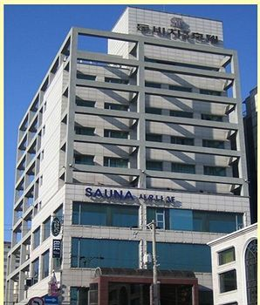
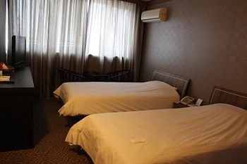
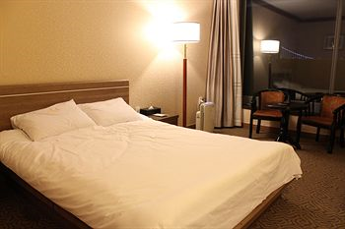
Located near Gwangan Beach in Busan, Dawn Beach Hotel features rooms with free internet access and cable TV. It features a lounge bar, coffee shop and free parking. Rooms at the Dawn Beach Hotel feature air conditioning and heating facilities. A sitting area, bathrobes and slippers are provided. Guests can relax at the hotel’s sauna. Karaoke facilities are available.
ROOM TYPE | PRICE(per room/2pax) | REMARK
Standard(Double/Twin) | $90 | Breakfast $10

4) Hotel Press
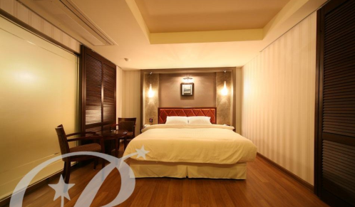
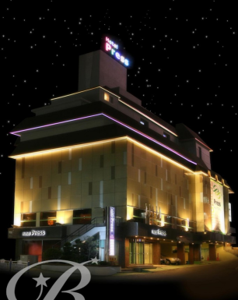
25-6, Namcheon-Dong, Suyeong-Gu, Busanhttp://presshotel.co.kr/
Hotel Press offers boutique accommodation in Gwangan Beach Area, 350 metres from Namcheon Subway Station (Line 2). The stylish hotel provides free parking and free Wi-Fi access on site. Guestrooms feature modern interiors and offer both heating and air-conditioning facilities. Each room comes with a personal computer, tea/coffee making facilities and a flat-screen TV with cable channels. The hotel’s restaurant serves a selection of local dishes. Laundry and dry cleaning services are available at this hotel. Other services include currency exchange and luggage storage. Hotel Press is located 2 km from the Gwangalli Beach, 4 km from BEXCO and 5 km from the Haeundae Beach. Gimhae International Airport is only a 30-minute drive away.

ROOM TYPE | PRICE(per room/2pax) | REMARK
Standard(Double) | $90(weekday)  $120(weekend) | Breakfast $10

5) Castle Beach Hotel
110-60, Minrak-Dong, Suyeong-Gu, Busan
http://www.castlebeach.co.kr/
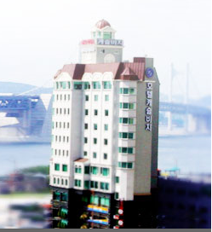
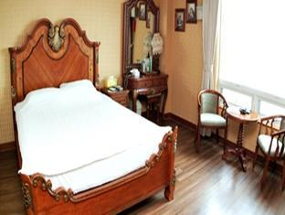
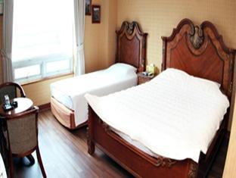
Located in Gwangan Beach, Castle Beach Hotel offers rooms with free internet and private bathrooms Each air-conditioned room features heating and a private balcony. Room amenities include a minibar, telephone and TV. Bathrobes and slippers are provided. Guests can enjoy Karaoke facilities. Luggage storage and a safety deposit box are available. Western, Japanese and Korean cuisines are served at the hotel’s restaurants.

ROOM TYPE | PRICE(per room/2pax) | REMARK
Standard(Double/Twin) | $80 | Breakfast $10

12. Surrounded Race Venue (Map)
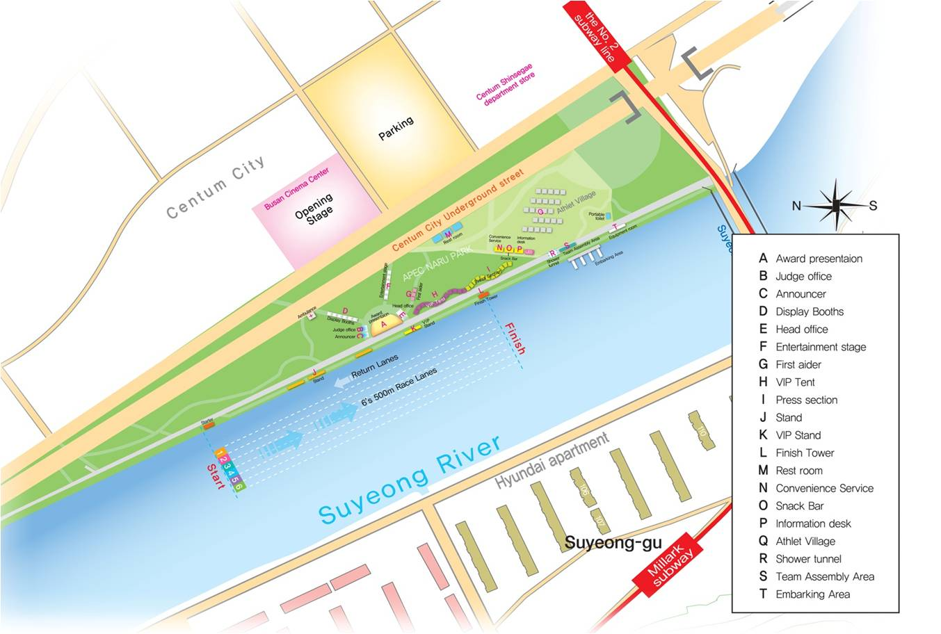
Official Accomodations surrounded Race Venue
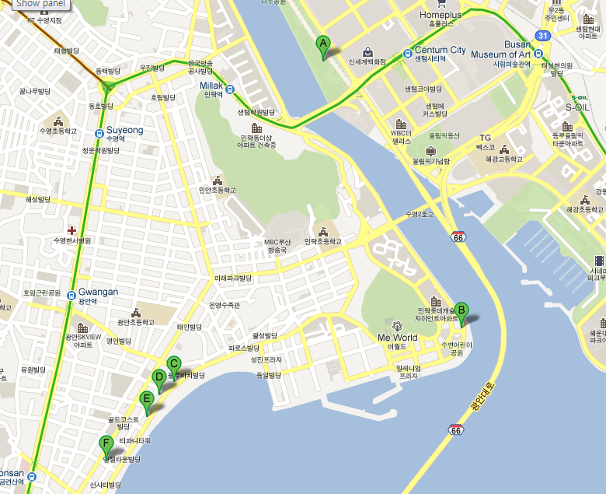
A. Official venue.
B. Castle Beach Hotel
C. Aqua Palace Hotel
D. Homers Hotel
E. Dawn Beach Hotel
F. Hotel Press

13. Submit Information to the Organizing Committee
1) Arrival & Departure Schedule

 | Date/Time | Flight No. | Arrival Airport
Arrival
Departure

2) Training Booking
Date | Time | Team name/Number of crews
1st Oct | 10:00-12:00
 | 13:00-15:00
2nd Oct | 10:00-12:00
 | 13:00-15:00

3) Flags and Anthems
Each participating team shall submit 2 national/regional flags (min. 144x96cm), 1cassette or 1CD of the national/regional anthem.

