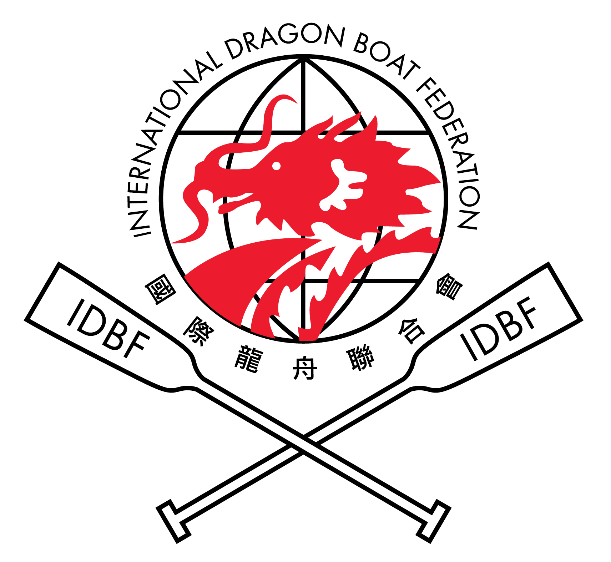
Hong Kong 2012 -4th – 8th July 2012
8th Club Crew World Championships

Victoria Harbour, East Tsim Sha Tsui, Hong Kong SAR, China

CREW INFORMATION SHEET
Please return before 30 April 2012
(A) NAME OF THE CREW and CLUB (show also Country or Territory)


(B) BRIEF DISCRIPTION OF THE CREW


(C) TITLES IN MAJOR CHAMPIONSHIPS or INTERNATIONAL RACES and NATIONAL CHAMPIONSHIPS at 500m.
Event Name | Year | Placing | Best Time

RETURN THIS SHEET BY E-MAIL TO HKDBA@HKOLYMPIC.ORG
with cc to ccwcentry@idbf.org

CONFIRMED ENTRIES
SHOULD BE SUBMITTED ELECTRONICALLY AT http://idbfworldchamps.com/registration.php
the Closing Date for Confirmed Entries is 1st APRIL 2012 – if entering via email send to:- ccwcentry@idbf.org.
Club Crew Name
Managers Name
E-mail Address
Number of People expected to travel to Hong Kong
Club Members * | Supporters ** | Media | Total Number
Arrival Date |  | Departure Date
* Includes all competitors, managers, coaches, medics, etc. ** includes sponsors, family, friends, etc.
Place an X in the boxes below for each Competition Class entered - One (1) Entry per Club per, Competition.
Mixed entries, if the competitors are from the Open and/ or Women’s crews, indicate this by marking C for combined.
Standard Boat  (22 Racers) | Open |  |  | Women |  |  | Mixed
Standard Boat  (22 Racers) | 200m | 500m | 2000m | 200m | 500m | 2000m | 200m | 500m | 2000m
Premier (any age)
Senior A 040
Snr B (GD) 050
18-23s
Junior A / B | / | / | / | / | / | / | / | / | /
BCS /ACS /APC | / / | / / | XXXXX | / / | / / | XXXXX | / / | / / | XXXXX
Standard Mixed Crews = min of 8, max of 12 female paddlers. Small Mixed Crews = min of 4, max of 6 female paddlers For ACS & AP crews, up to 4 crew members (2 in the Small Boat) may be cancer free or non Paradragon competitors.
Small Boat  (12 Racers) | Open |  | Women |  | Mixed
Small Boat  (12 Racers) | 200m | 500m | 200m | 500m | 200m | 500m
Premier (any age)
Senior A 040
Senior B (GD) 050
18-23s
Junior A – U18
Junior B – U16
BCS /ACS / APC | / / | / / | / / | / / | / / | / /
Age Regulations: Seniors A – age 40 or over. Senior B (Grand Dragons) 50 or over, as of 1 June 2012
Junior A – aged under 18 but 12 or over as of 1 January 2012. Junior B - Under 16 but 12 or over as of 1 January 2012
18s - 23s – aged 18 to 23 years old as of 1 June 2012 (Standard Boat 4 crew members may be 16-17 & 2, 24-25 – Small Boat 3 & 1)
Reserve Paddlers: Maximum of Four (4) in a Standard Boat Crew and two (2) in a Small Boat Crew

UNIVERSITY DORMITORIES BOOKING FORM

Please fill in BLOCK Letters. TO BE RETURNED BEFORE 31ST MARCH 2012
Club Crew Name
Contact Name
Phone/Fax Number
E-mail Address
Accommodation (Please indicate below the number of room requirements):
Hong Kong Baptist University – NTT International House
Room Type | Total number of rooms | Date of reservation
Superior Room – HK$585
Deluxe Room – HK $850

The Hong Kong Institute of Education – Student Rooms & Flats
Room Type | Total Number of flats / rooms | Date of reservation
9-person flat - HK$1,400
12-person flat - HK$2,000
Twins Room - HK$320

Total Cost: HK$_______________________

Flights Schedule
 | Country (From) | Country (To) | Flight No. | Date | Time
Arrival
Departure

Crew Manager - Name
Signature
Date
RETURN THIS FORM WITH REMITTANCE ADVICE TO ORGANIZING COMMITTEE BY
EMAIL TO:- HKDBA@HKOLYMPIC.ORG FAX: +852 - 25771873

Celebration Dinner Party Booking Form

Please return before 30 April 2012
Please fill in BLOCK Letters.
Club Crew Name
Contact Name
Phone/Fax Number
E-mail Address
Name of hotel
Address of hotel
Indicate below the number of seat requirements:
Club members | Supporters | Media | Total Number

Total Cost: US$20 x ________________seats = US$ ______________

Crew Manager – Name _____________________
Signature _______________________________

Date _____________________

RETURN THIS FORM WITH REMITTANCE ADVICE TO ORGANIZING COMMITTEE
by
EMAIL TO:- hkdba@hkolympic.org FAX: +852 - 25771873

Transport Booking Form

CREWS NOT IN OFFICIAL HOTELS & UNIVERSITIES DORMITORIES
Please fill in BLOCK Letters. TO BE RETURNED BEFORE 30th APRIL 2012
Club Crew Name
Contact Name
Phone/Fax Number
E-mail Address
Port of entry
Name of hotel
Address of hotel
Indicate below the number of coaches required:
 | Between port of entry and hotel | Hotel to race site | Race site to hotel
1/July
2/July
3/July
4/July
5/July
6/July
7/July
8/July
9/July
Flights Schedule
 | Country (From) | Country (To) | Flight No. | Date | Time
Arrival
Departure

Crew Manager – Name ____________________________Signature _______________________
Date ____________________
RETURN THIS FORM TO THE ORGANIZING COMMITTEE BY EMAIL TO:- johnmong@hstul.com
with cc to hkdba@hkolympic.org fax: +852 – 25771873

