DBS MARINA REGATTA 2012
Marina Reservoir, Singapore
4th & 6th May 2012

HOW TO SUBMIT PHOTOGRAPHS

- Every crew member (i.e. Team Manager, Coach, Paddler, Drummer and Steersperson) must submit a digital photograph of himself/herself.

- Each digital photograph must be of international passport size (i.e. approximately 4.5cm x 3.5cm) and must be submitted in soft copy, in JPEG format (digital size between 20-100kb).

- The file name of the JPEG photograph must be the name of the crew member registered for (i.e. exactly the same name as entered in Form “F2 Summary of Participants”). An example of JPEG photographs filed in a folder in the computer is shown below:

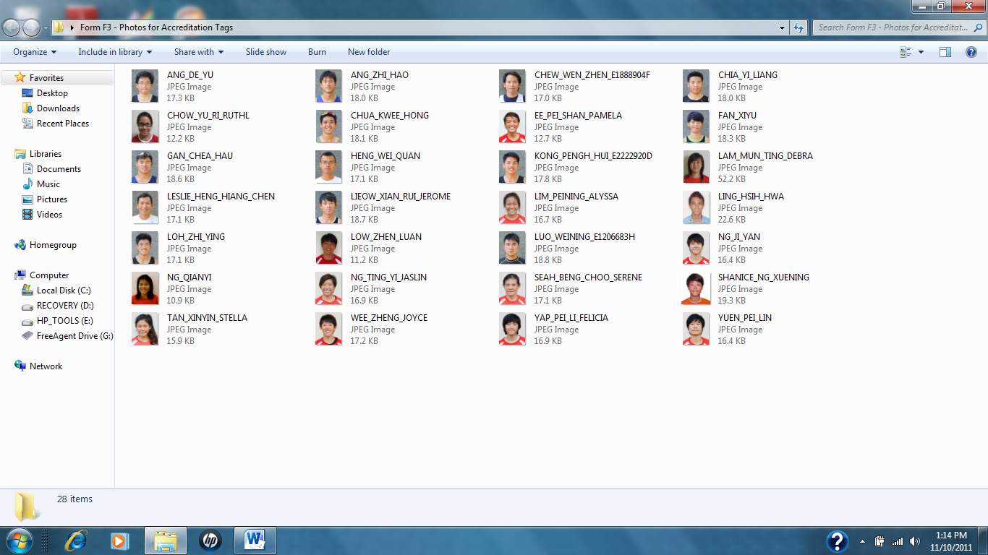

- Entries received after the closing date or those that are still without photographs, will not have their Accreditation Tags made before race day.

Accreditation Tags made after the closing date or processed as late entries on race day will be subjected to a penalty of S$50.00 per tag.

