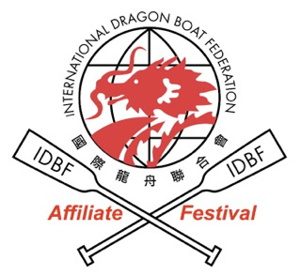

33RD PENANG INTERNATIONAL DRAGON BOAT FESTIVAL 2012
PROVISIONAL ENTRY FORM
(CLOSING DATE: 31 JANUARY 2012)

Name of Crew : _____________________________________________
团队名称
Name of State/Country : _____________________________________________
团队国籍
Name of Crew Manager : _____________________________________________
领导姓名
No. of crew members : ________ male名男队员+ ________ female名女队员= ______________
队伍成员
Telephone No. / Fax : (H/P) 手机__________________(Fax) 传真__________________
联络号码 / 传真
E-mail Address : _____________________________________________
电子邮件
Races Participating : (Please indicate the no. of entries in the white boxes)
赛事参与及次数 (请在格内填写参赛次数)
22 Racers | Open |  | Mixed
22 Racers | 200 m | 500 m | 200 m | 500 m
Premier

12 Racers | Open |  | Women |  | Mixed
12 Racers | 200 m | 500 m | 200 m | 500 m | 200 m | 500 m
Premier
Senior 40
Junior U23
Inter-Factory

Total no.of events : __________项
总共参与的项目
Crew Manager’s Signature: _______________________ Date : _______________
领队签名 日期
Contact Information

Mailing Address: | 11-A Lorong Pulau Tikus  10350 Penang  Malaysia
Contact: | Tel: +604 650 5136  +6012 483 0448  Fax: +604 228 0448
Email: | secretary@penangdragonboat.gov.my
Website: | www.penangdragonboat.gov.my
Facebook: | https://www.facebook.com/penangdragonboat

